ML :

-----SivaaShaanth-----

2015103048

1. **How we can avoid the overfitting in Decision Tree**

CHAID(Stopping the Tree Growth)

Pruning the Full Grown Tree

Both of above

None of the Above

Answer C

1. **In Classification Model, Which Technique can help you to choose a threshold that balance sensitivity and specificity**  a) Confusion Matrix b) ROC Curve c) MAPE (*mean absolute percentage error)* d) None of the Above

Answer B

1. **Random Forest Modeling (Ensemble Modeling) uses**

a.Bagging(BootStrap Samples)

b.Boosting

c.Both of above

d.None of the Above

Answer A

1. **Which of the following statement(s) is/are true?**

**(i) Genetic Algorithm is a randomised parallel search algorithm, based on the principles of natural selection, the process of evolution.**

**(ii) GAs are exhaustive, giving out all the optimal solutions to a given problem.**

**(iii) GAs are used for solving optimization problems and modeling evolutionary phenomena in the natural world.**

**(iv) Despite their utility, GAs remain a poorly understood topic.**

**Your****answer is :**

(a) i, ii & iii only (b)ii, iii & iv only (c)i, iii & iv only (d)all of the above

Answer C

1. **Which of the following is supervised ?**

Linear Discriminant Analysis

Principal Component Analysis

Both

None

Answer A

6**.K-means clustering aims to partition n observations into k clusters in which each observation belongs to the cluster with the nearest -----------**

A Mean

B Median

C Mode

D None

Answer B

7 **K-Means squared error function is related with which of the following?**

A Manhattan distance

B Hamming distance

C Euclidean distance

D Minkowski distance

Answer C

8. **Which of the following(s) is/are the prerequisite(s) when Genetic Algorithms are applied to solve problems?**

**(i)encoding of solutions**

**(ii)well-understood search space**

**(iii)method of evaluating the suitability of the solutions**

**(iv)contain only one optimal solution**

Youranswer is :

(a)i & ii only (b)ii & iii only (c)i & iii only (d)iii & iv only

Answer C

9 **Which of the following is true?**

**1)In bagging trees, individual trees are independent of each other**

**2)In boosting trees, individual weak learners are independent of each other**

A. Only 1

B. Only 2

C. Both 1 and 2

D. Neither 1 nor 2

Answer A

10  **Which of the following algorithm are not an example of ensemble learning algorithm?**

A) Random Forest

B) Adaboost

C) Gradient Boosting

D) Decision Trees

Answer D

ML

________Sreevatsan________

1 :

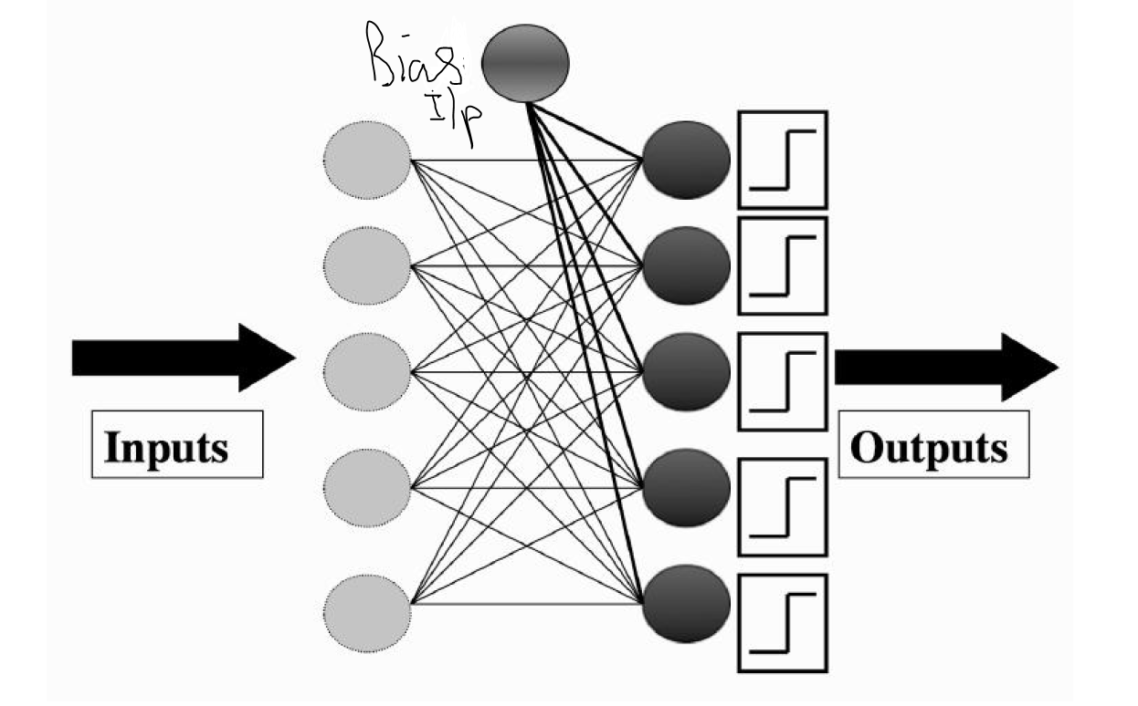**What is the value of bias input in a Perceptron?**

A : 0  
B : 1

C : -1

D : Depends on learning rate **η**

E : None of the above

ANSWER : C

2 : **Which logic function can not be implemented using a single-layer perceptron?**

A : OR

B : XOR

C : NOT  
D : AND

E : NOR

ANSWER B

3 : **Which is the type of learning associated with learning from examples?**

A : Reinforced Learning

B : Unsupervised Learning

C : Evolutionary Learning

D : Supervised Learning

E : Last Minute Learning

ANSWER : D

4 : **Which algorithm starts off with the entire version space ‘ H ‘ that shrinks down to one hypothesis ( ideally ) ?**

A : Find- S algorithm  
B : Candidate elimination algorithm

C : Dijkstra algorithm

D : List-then-eliminate algorithm

E : None of the above

ANSWER : D

5 :

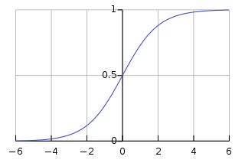

**What function does this graph represent?**

A : Sine function

B : Sigmoid function

C : Solenoid function

D : Logarithmic function

E : Autocorrelation function

ANSWER : B

6 : **What is back propagation?**

A : It is another name given to the curvy function in the perceptron

B : It is the transmission of error back through the network to adjust the inputs

C : It is the transmission of error back through the network to allow weights to be adjusted so that the network can learn

D : It is the transmission of the output back to the input so that the weights can learn

E : None of the mentioned

ANSWER : C

7 :

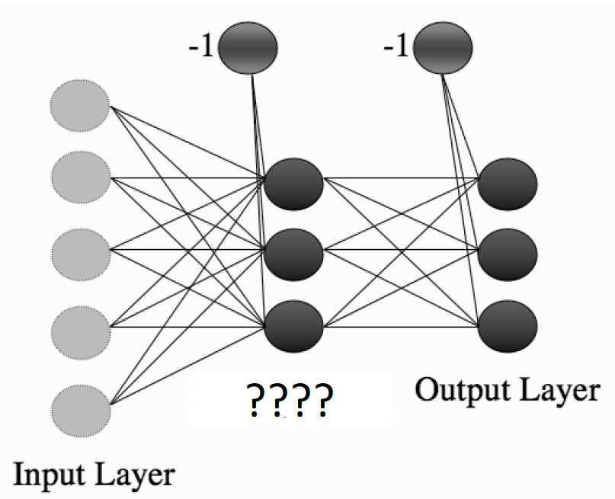

**What is that layer called ?**

A : Processing layer

B : Perceptron layer

C : Hidden layer

D : Bias layer

E : Learning layer

ANSWER : C

8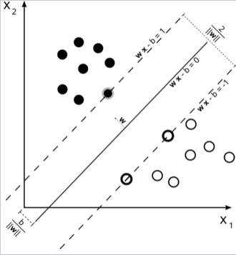 :

**In the above diagram, what are the support vectors?**

A : The line dividing the samples into the classes equally

B : Outliers

C : The margin passing through the samples

D : The samples lying on the margin

E : The outliers near the line passing through the margin

ANSWER : D

9 :  **What do you call it when we find the projected mean of samples of a various classes , maximize the function that represents the difference between the means and normalize by a measure of the within-class variability?**

Linear regression

Random forests

Linear discriminant analysis

Principal component analysis

E : None of the above

ANSWER : C

10 : **“The changes in the strength of synaptic connections are proportional to the correlation in the firing of the two connecting neurons”**

**What is this rule called as ?**

A : McCulloch’s rule

B : Hebb’s rule

C : Karush–Kuhn–Tucker ‘s rule

D : Optimal Separation rule

E : Marsland’s rule

ANSWER : B

TOC -- Vigneshwaran D

**1 . Correct hierarchical relationship among context- free, right-linear, and context-sensitive language is**

A: context-free ⊂ right-linear ⊂ context-sensitive

B: context-free ⊂ context-sensitive ⊂ right-linear

C: right-linear ⊂context-free ⊂context-sensitive

D: context-sensitive ⊂ right-inear ⊂context-free

**2 . The major difference between a moore and mealy machine is that**

A: output of the former depends on the present state and present

input

B: output of the former depends only on the present state

C: output of former depends only on the present input

D: all of the above

**3. Finite State Machine can recognize**

A: any grammar

B: only CG

C: Both (a) and ( b )

D: only regular grammar

**4. An FSM (Finite State Machine) can be considered to be a TM (Turing Machine) of finite tape length**

A: without rewinding capability and unidirectional tape movement.

B: rewinding capacity, and unidirectional tape movement

C: without rewinding capability and bidirectional tape movement

D: rewinding capability and bidirectional tape movement

**5. Palindromes can't be recognized by any FSM because**

A: FSM can't remember arbitrarily large of information

B: FSM can't deterministically fix the mid-point

C: even if mid-point is known, FSM be can't be found whether,

second half of the string matches the first half

D: all of these

**6. An FSM with**

A: 1 stack is more powerful than an FSM with no stack

B: 2 stacks is more powerful than a FSM with 1 stack

C: both (a) and (b)

D: none of these

**7. Which of the following statements is wrong ?**

A: The language accepted by finite automata are the languages

denoted by regular expressions

B: For every DFA there is a RE denoting its language .

C: For every expression r , there does not exist NFA with L(r) any transit that accept .

D: None of these

**8. An automation is a __________ device and a grammar is a __________ device.**

A: Generative ,cognitive

B: Generative , acceptor

C: Acceptor , cognitive

D: Cognitive , generative

**9. Running time of NFA to DFA conversion including the case where NFA has e-transition is**

A: 0 (n3)

B: 0(n332)

C: 0(n32n)

D: 0(n22n)

**10. Consider regular expression (0 + 1) (0 + 1) ....... n times. Minimum state finite automaton that recognizes the language represented by this regular expression contains**

A: N states

B: N+1 states

C: N+2 states

D: None of the above .